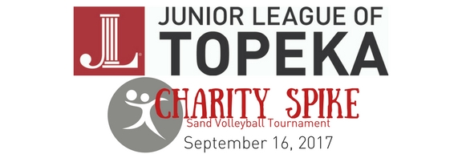
Sponsorship Levels
Premiere-$500 (one available)
*Top logo placement on event poster
*Top logo placement on back of event t-shirt
*3 items in participant swag bag (to be provided by sponsor)
*Sponsor mention on website, TV, and weekly public social media posts regarding event
*Team entry into tournament
Gold-$250 (two available)
*Logo on event poster
*Logo on event t-shirt
*2 items in participant swag bag (to be provided by sponsor)
*Sponsor mention on website and weekly public social media posts regarding event
*Team entry into tournament
Silver-$100 (unlimited)
*Logo on event poster
*Logo on event t-shirt
*1 item in participant swag bag (to be provided by sponsor)
*Sponsor mention on weekly social media posts regarding event
* ½ price team entry into tournament
Bronze- <$100 (unlimited)
*Logo on event poster
*Logo on event t-shirt
*Sponsor page mention on weekly social media posts regarding event

